Lab 3 – Transform data with SQL

1. Provision an Azure Synapse Analytics workspace

1. View files in the data lake

1. Use SQL to query CSV files

1. Create an external data source and file format

1. Create an external table

1. Encapsulate data transformation in a stored procedure

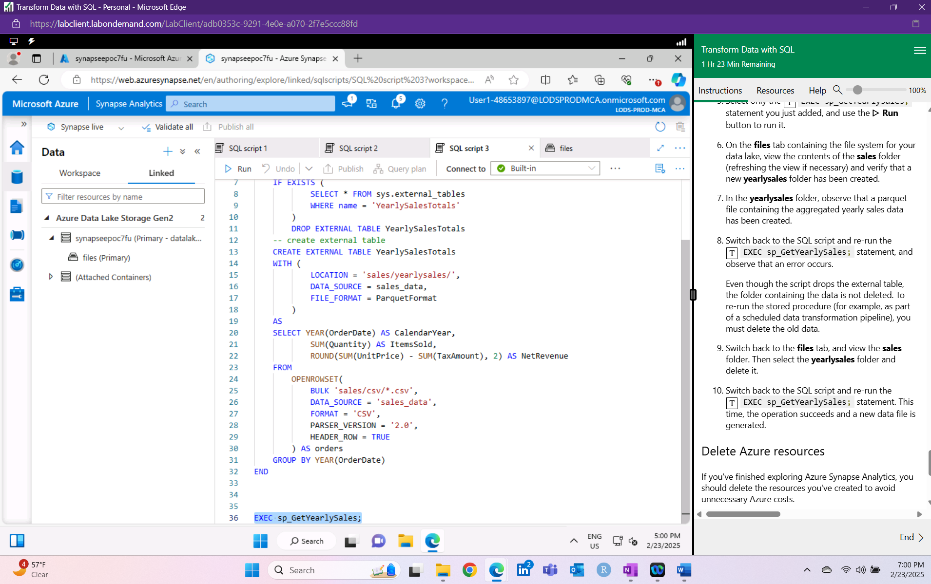

1. Delete Azure resources

Summary:

Data analysts and engineers use SQL for querying, transforming, and managing data. In this process, we use the serverless SQL pool in Azure Synapse to transform data. First, we provision an Azure Synapse Analytics workspace by cloning a Git repository and running a setup script. After exploring and querying CSV files in the sales folder of the data lake, we use CETAS (Create External Table as SELECT) to create external tables and export results. A stored procedure is defined to drop and recreate the external table while loading yearly sales data. Although the table is dropped, the data folder remains, so we deleted it manually before rerunning the procedure to generate updated data ready for querying. Once completed, we deleted the Azure resource group to stop the lab environment.